MISSION STATEMENT
The Purdue University Dorothy Stratton Veteran and Military Success Center (VMSC) will provide wholistic programming and services for students who are veterans (V), currently serving members of the military (M), and benefit-using family members (F)—known collectively as VMF.

VISION STATEMENT
The VMSC aspires to improve access, retention and graduation rates of VMF students as well as increase confidence in the career search process and provide opportunities to connect with potential employers. The VMSC aspires to increase Purdue’s national recognition as a leader in supporting VMF students.

PROGRAM ELEMENTS
The Dorothy Stratton Veteran and Military Success Center provides five broad levels of VMF support:
- Servicemember Education Benefit Program Excellent Stewardship and Advocacy
  - Maintain the GI Bill® program and administer good stewardship of program elements such as compliance, auditing and reporting to respective agencies to ensure cross-campus procedures and policies foster support for VMF students who use the GI Bill program.
  - Administer Department of Defense (DoD) Voluntary Education Program Federal Tuition Assistance (FTA) to eligible VMF students by upholding program elements through compliance, auditing and reporting to respective parties to ensure cross-campus procedures and policies support elements of the program.
  - Provide and advocate for cross-campus collaboration to mitigate risk when administering servicemember education benefits, the GI Bill, FTA and specific state-funded benefits (NGSG, CVO and Purple Heart).
  - Facilitate the process for the military absence policy and the military withdrawal with Purdue’s Enrollment Management.
  - Administer the adjudication of establishing in-state tuition for VMF students for six specific classifications with the office of the Registrar.
  - Implement and administer all nationwide and state-wide changes to servicemember education benefit programs and ensure campus adjustments to procedures, legislation and agency policies to maintain good stewardship.
  - Directly advocate for students and improve campus VMF awareness through Green Zone workshops and student panels.
- Student Orientation and Onboarding: An in-depth orientation and peer program to support incoming VMF students.
- The Purdue Student Veterans Organization (PSVO): This active student organization was created in 2005 and is open to the entire VMF population. Members advocate for campus change, community service and shared camaraderie. Both the director and assistant director for the VMSC serve as advisors.
- Education to Occupation (E2O): This program helps VMF students transition from higher education to career by creating transition awareness, strengthening self-advocacy and facilitating connections with employers. Initiatives include target employer programming and networking opportunities.
- Student Space: The VMSC physical space at Purdue University West Lafayette houses staff, federal work-study students, the PSVO and study space for VMF students. The space is accessible and equipped with resources to support students’ academic needs. Through the Shared Services Agreement between Purdue University and IU Indianapolis, Purdue students studying in Indianapolis are welcome to visit and participate in activities associated with IU’s Office for Veterans and Military Personnel on the Indianapolis campus.

PROGRAM OUTCOMES
Benefits and Advocacy
- The GI Bill Program
  - Respond to Department of Veterans Affairs (VA) representatives throughout the year to report tuition and fees on behalf of GI Bill users.
  - Collaborate with campus partners to submit curriculum updates so Purdue’s updated annual catalog is available to GI Bill users.
  - Ensure initial and dual certifications are completed in a timely manner on behalf of GI Bill users.
  - Respond to the VA compliance system by collecting campus information and student case information related to student questions to the VA.
  - Remain in compliance with the 8 Principles of Excellence and advocate for good stewardship of the GI Bill program in order to mitigate risk.
  - Conduct frequent GI Bill audits to ensure enrollment and financial changes are reported and errors are corrected.
  - Respond to VA debt processing and work closely with Purdue Bursar, VA and other agencies.
- DoD Voluntary Education Program Federal Tuition Assistance (FTA)
  - Provide annual auditing self-compliance reports to remain in good standing with the University’s Memorandum of Understanding (MOU) and remain eligible for program continuation.
  - Ensure feedback from compliance reporting is communicated to respective campus partners and implemented into their processes and procedures.
  - Respond to the DoD compliance system by collecting campus information and student case information related to student inquiries to the DoD.
  - Remain in compliance with the 8 Principles of Excellence and advocate for good stewardship of the GI Bill program to mitigate risk.
  - Assist individual students in course and grade uploads
- All Servicemember Education Benefits
  - Ensure campus partners are trained on relevant education benefits on a semesterly basis.
  - Advise students on benefits and the complexities of each benefit (federal, state and service-connected).
  - Staff maintain benefits proficiency by attending conferences and continuing education.
  - Administer priority registration status for eligible students
- The Collegiate Purple Star Initiatives
  - Administer course equivalency review on the Joint Service Transcript
  - Administer Purple Star Scholarship for eligible TA users
- Campus Advocacy
  - Increase campus awareness of the unique attributes of VMF students by hosting Green Zone workshops for Purdue faculty and staff.
  - Provide education benefits awareness training through administering trainings on Residency Process, Military Withdrawal/Absence Leave Process, FTA process, and JST process to campus partners

Student Leaders
- Provide the opportunity to attend the Student Veterans of American Leadership Institute (LI) and the National Student Veterans of America Conference (SVA).
- Provide several opportunities throughout the year for professional growth.
- Administer Work Study program in alignment with GI Bill Program

Military-Affiliated Students
- Provide the opportunity to understand their benefits and maintenance of these benefits.
- Provide opportunities for camaraderie within the office.
- Provide need-specific items, such as a Common Access Card (CAC) accessible computer and CAC card reader.
- Host military population specific events such as the military connected career fair,

ASSESSMENT PLAN
- Continue to monitor census data for changes in demographics and characteristics of VMF students.
- Prepare and respond to VA compliance surveys and understand how individual student file findings perform by ratio.
- Use WEAMS software to verify new Purdue programs are updated and available to GI Bill users.
- Capture the number of complaints filed through other agencies and pinpoint the true nature of the errors.
- Respond to feedback provided by the DoD self-compliance annual report.
- Respond to feedback provided by the VA compliance surveys.
- Report prevalent information about GI Bill users to respective agencies.
- Monitor internal procedures and cross-campus procedures to mitigate risk errors made by the university when administering the GI Bill program.
- Capture the number of annual tuition and fees posted for VMF students.
- Capture FTA users, preferably by branch.
- Capture Purdue Online growth by monitoring enrollment and program growth.
- Collect pre- and post-surveys for Green Zone participants.
- Aspirational data
  - Collection of Residency classifications. For example, which classification has the most applications?
  - Collection of findings from internal auditing and billing codes.
  - How many military withdrawals are processed throughout the year?
  - VMSC did start a business analysis project tracking the workflow of servicemember education benefits. During August of 2025 – they are in the process of finding vendors that may meet business needs to amplify record keeping and data tracking efforts.
  - True VREC analysis – currently the VMSC has no accurate way of tracking the intake of VREC’s

NOTABLE CHANGES FROM 2024-25 ACADEMIC YEAR
Staffing & Space
  - One Certifying Official retired in October 2023. The backfill request was approved in September 2023 and the position was filled in January 2024.
    - This position became vacant on January 21, 2025
    - This position became filled on September 2nd, 2025
  - A new position, the VMSC’s 5th SCO was approved on April 3rd, 2024 because of increased population from Purdue in Indianapolis.
    - Position posted on April 17th, 2024
    - A new computer system was ordered on April 7, 2024
    - A new desk station was ordered on April 30, 2024
    - Position was filled on July 29, 2024
    - This position became vacant on August 5th, 2025
    - Position is still open and in search as of September 27th, 2025
  - Findings from data supported a need for an additional Certifying official to support Purdue Online due to the campuses nature of non-credit programs generating more certificates than Purdue WL campus (for example). There is a pending unfulfilled position request that rests with the Provost office.
  - Each staff member rotates remote work from home one day a week. This schedule expands around holidays and over the summer for retention and staffing purposes.
  - The VA GI Bill Work Study Program continued at Purdue West Lafayette for 7 students in Fall 2024 and 5 students in Spring 2025. We had 1 consistent summer work study student.
  - On February 27, the VMSC requested renewal of 2 terms (24 months) as our lease was set to expire June 30, 2024.

Notable Mentions
- From August 2023 – July 31, 2024, the Veteran and Military Success Center processed certifications and residency applications which totaled $13,097,182.
  - Residency: $2,992,000.00
  - The GI Bill program: $9,376,903.35
  - Federal Tuition Assistance: $728,279.13
- Kimberly Heslin received a Bravo award in Spring 2025 for bringing in over assisting and stepping in while Federal Tuition Assistance posed challenges that ROTC department navigated with her assistance and for her steadiness in excellent management of the FTA program
- Morgan Gamble received a Bravo award in Spring 2025 for efforts made for the Collegiate Purple Star Initiative Application
- Bryan Arbic attended the NASPA Military Symposium in Louisville, Kentucky.
- Teresa Harris was promoted in January 2024 to the Program Manager of Service Member Education Benefits
- Certifying officials attended the Association of Veterans Education Certifying Officials (AVECO) conference.
- The VMSC continues to serve as a member of the Presidential National Security Defense Council (NSDC).
- Morgan Gamble continues to serve her Gubernatorial Appointment as a Commissioner to the Indiana Department of Veterans Affairs.
- Prepared and submitted application with the State of Indiana regarding the Collegiate Purple Star Initiative
  - Fall 2024 – Purdue launches first ever Joint Service Transcript Review of Course Equivalency process and is successful in grating course equivalent credits
  - Spring 2025 – Purdue receives notice of 1st Tier Designation for Collegiate Purple Star Initiative
  - Fall of 2025 – Purdue launches first ever Collegiate Purple Star Fee Remission for eligible Federal Tuition Assistance students
- Teresa Harris and Morgan Gamble attend a meet and greet with the Indiana State Approving Agency (SAA) in July 2024.

Administrative, Benefits and Legislative Changes
- Internal processes as they pertain to Administrative Elements of Servicemember Education Benefits
  - Residency: A process administered by the Veteran and Military Success Center to fully receive residency applications and adjudicate decisions to the Bursar and the student. The VMSC administers a manual process of adjudicating all military-related residency applications. The VMSC has an in-house application and standard operating procedures for establishing an out-of-state student as an in-state student for the purpose of military tuition and fees only. After successfully piloting this program in Spring 2023, the Office of the Registrar designated the VMSC as the official adjudicators and hosts of the military residency application for all six military-connected categories (listed below). This was a welcome win by both offices as it minimizes time delegated toward the process, improving the student and ensuring compliance with policy, state and federal law. This process also minimizes errors and cleans up several internal processes for reporting to respective agencies about accurate tuition and fees.
- Active-Duty Military Personnel and Dependents
- Indiana National Guard and United States Military Reserves
- Resident Veterans Living in Indiana
- Non-Residency Veteran: Non-Resident Veteran living in Bordering States (IL/KY/OH/MI)
- Military Personnel Serving on USS Indiana (SSN-789)
- The Veterans Access, Choice, and Accountability Act and Choice Act Updates
  - As of September 25, 2024, the Montgomery GI Bill Selected Reserves Tuition Fairness Act of 2024 passed within the House. This bill requires the Department of Veterans Affairs to disapprove courses that charge higher than in-state tuition for individuals using the Montgomery GI Bill Selected Reserve education benefits while living in the state where the education is located, regardless of the individual’s state of residence.
  - In 2023, the VMSC adjudicated a total of $3,060,000.00. In 2024, the VMSC adjudicated a total of $4,148,000.00. Data from this process is on the next page.

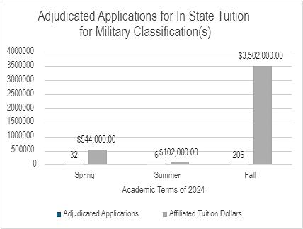
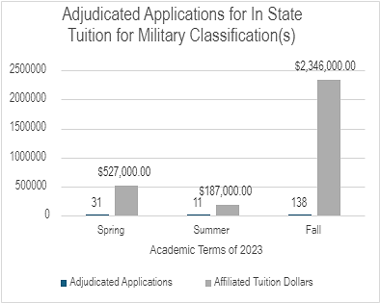
  - Purdue Polytechnic Institute (PPI): The VMSC continues to support GI Bill Certifications at all PPI locations per the renewed MOU.
    - Timeline
      - In May 2023, a memo was signed by Christina Haddock from PPI. This memo supported funding for the VMSC from July 1, 2023 through June 30, 2024. An updated version was signed in May 2024.
      - The VMSC requested renewal of this memo on February 13, 2024.
      - In March 2024, a memo was signed by Daniel Castro from PPI. This memo supports funding for the VMSC from July 1, 2024 through June 30, 2025.
    - MOU Stipulation(s)
      - Per the MOU, training was conducted on April 22, 2024 with 27 people in attendance.
      - The certifying official performing the certification will collect the reporting fees connected to that specific service.
    - The MOU supports the following campuses for Purdue Polytechnic:
      - Polytechnic Statewide Anderson
      - Polytechnic Statewide Columbus
      - Polytechnic Statewide Indianapolis
      - Polytechnic Statewide Kokomo
      - Polytechnic Statewide Lafayette
      - Polytechnic Statewide New Albany
      - Polytechnic Statewide Richmond
      - Polytechnic Statewide South Bend
    - This past year there was a decrease in the percentage of support from PPI. The remaining was covered by the Provosts Office to fund the full 1.0 of a position.
- Internal Processes as they pertain to Education Benefits Elements of Servicemember Education Benefits

  - State Approving Agency (SAA) Campus Compliance Efforts – The Catalog: Each year, schools may update and add to their course offering through their course catalog. For a student to use their GI Bill education benefit towards curriculum offered by the school, the school must submit an application with information about each individual course included in this updated catalog. This process involves the collection of documents from multiple sectors of campus to report to the State Approving Agency. Information can include information about professors’ credentials, technology available in the classroom, power of attorney information, auditing reports and much more. Overall, the collection of materials can spread across 12 different campus departments and consist of over 136 pieces of information.

  - The Process:

    - The office that oversees the GI Bill program gathers materials for catalog process application with the State Approving Agency.
    - The office submits their information on behalf of the school to the State Approving Agency.
    - The State Approving Agency conducts its review and may request more information from the school.
    - The State Approving Agency sends its recommendations to the VA.
    - The VA updates their internal software to approve the student using the GI Bill with the newly approved course(s).
    - Purdue West Lafayette Catalog
      - Academic Year: 2021 – 2022: Catalog submitted and approved.
      - Academic Year: 2022 – 2023: According to VA regulations at this time, there is no need for Catalog submission, only amendments were submitted this year for review.
      - Academic Year: 2023 – 2024:
        - Catalog submitted on September 14, 2023.
        - This catalog was approved on June 18, 2024.
        - The effective date for this catalog was set for August 21, 2023.
          - Results: 103 programs approved, 14 pending
          - When programs are not approved and are considered pending the VMSC must go back and forth to the program administrators providing and advocating for proper documentation for approval.
      - The next catalog is projected to be due:
      - This is subject to change according to VA regulations, Federal Legislation, and State Approving Agency Guidance.
        - This is the process as of November 5, 2024.

    - Purdue Polytechnic Institute Catalog (PER PPI MOU p. 7)
      - Academic Year 2023 – 2024:
      - The next catalog is projected to be due Fall 2024. VMSC sent this catalog to the State Approving Agency on September 23, 2024
      - Approval Status and Results: pending
      - This is subject to change according to VA regulations, Federal Legislation, and State Approving Agency Guidance.
        - This is the process as of November 5, 2024.

    - Purdue Online Catalog
      - Academic Year 2023 – 2024: Amendments were only required and sent September 30
        - Results: Amendments approved on October 24.
      - The next catalog is projected to be due: After June 1, 2024
      - This is subject to change according to VA regulations, Federal Legislation, and State Approving Agency Guidance.
        - This is the process as of November 5, 2024.
  - State Approving Agency (SAA) Campus Compliance Efforts – Auditing/Reporting (85/15 and 35%)
    - 85/15 Auditing
      - Purdue West Lafayette & Purdue Online:
        - 85/15 Report was submitted to the ELR on Sept. 19, 2023
          - Purdue received approval for 35 Form on November 8, 2023
          - Due Next: Fall 2025
      - Purdue Polytechnic:
        - 85/15 Report was submitted to the ELR on Sept. 18, 2023
          - Purdue received approval for 35 Form on Nov. 13, 2023
          - Due Next: Fall 2025
    - 35% Form
      - Purdue West Lafayette & Purdue Online:
        - was submitted to the ELR on Sept. 19, 2023
          - Purdue received approval for 35 on Nov. 8, 2023
          - Due Next: Fall 2025
      - Purdue Polytechnic:
        - was submitted to the ELR on Sept. 18, 2023
          - Purdue received approval for 35 on Nov. 13, 2023
          - Due Next: Fall 2025
      - Lafayette:
        - was submitted to the ELR on Sept. 18, 2023
          - Purdue received approval for 35 on Nov. 13, 2023
          - Due Next: Fall 2025
      - Kokomo:
        - was submitted to the ELR on Sept. 18, 2023
          - Purdue Received an approval for 35 on Nov. 13, 2023
          - Due Next: Fall 2025
      - Indianapolis:
        - was submitted to the ELR on Sept. 18, 2023
          - Purdue received an approval for 35 on Nov. 13, 2023
          - Due Next: Fall 2025

    - Relevant Veterans Affairs Agency Regulation Update: Approved Rule 56 – effective February 15, 2024, VA Amended its restriction on enrollment regulation for enrollment periods beginning on and after January 16, 2024, to include all 85/15 waivers pending before VA on that date.
    - Approved Rule 56 made the following key changes:
      - Amends the definition of supported students by removing exceptions for unrestricted and graduate student institutional aid.
      - Amends criteria VA evaluates when a school applies for the Education Service Waiver.
      - Requires schools with programs not otherwise exempt from 85/15 to create, and if required, submit the 85/15 calculations within 30 days of the beginning of each non-standard form.
      - This is subject to change according to VA regulations, federal legislation, and State Approving Agency Guidance. This is the process as of November 5, 2024.

Purdue Indianapolis Catalog and Setting up Facility Code:
Once information about the IUPUI decision had become final, the Veteran and Military Success Center acted fast to maximize their process to extend the GI Bill benefit program to the Indianapolis location, which required filing with the State Approving Agency and the Department of Veterans Affairs an additional facility code.

Facility Code: A facility that provides services to a GI Bill user according to the GI Bill program offered by the VA, must have on record site location, information, application, and much more information so that it can serve as a valuable administrative component to administering the GI Bill program efficiently and accurately. Purdue West Lafayette has a facility code, as does each of the Purdue Polytechnic locations.

This process required us to gather 106 pieces of cross-campus information about Purdue Indianapolis, involving more than 24 separate offices. As a result of this effort, there were 254 consultations made to support this endeavor. Pieces of this application included the University leadership signature on Executive Order Compliance Documents, Power of Attorney information, Treasury Office Direct Deposit information, Fire Inspection Data, a physical State Approving Agency Inspection and report findings, and much more.

We gathered as many elements as we could prior to June 2024. June 2024 was the suspected date for the release of the Catalog by the office of the Registrar for Purdue WL and Purdue Indianapolis. The final piece of information needed for the process to submit for a facility code and catalog at the Purdue Indianapolis location. Once June came, we collected the catalog and most information about the courses found in the catalog. For the academic year 2023–24, the catalog submitted on July 19, 2024 and approved on August 9, 2024.

- Internal Processes as it pertains to Education Benefits Elements of Servicemember Education Benefits
  - VA Compliance Survey(s): the purpose of a Compliance Survey is to ensure that approved programs are compliant with all applicable provisions of Title 38, United States Code (USC) Section 3693 administered by the VA.
    - Academic Year 2023–24:
      - Last date of Approval (found in WEAMS): August 21, 2023
      - Most Recent Survey:
        - Official Notification received by VMSC on May 6, 2024, to conduct an audit from January 19, 2021 – March 3, 2024.
          - Entrance Briefing held and conducted by Education Compliance Survey Specialists on May 20, 2024
          - Exit Briefing held on May 21, 2024
          - Findings submitted to the school on May 28, 2024
            - (4) findings
  - Complaints Filed through the VA: (2)
    - These complaints were responded to by the Veteran and Military Success Center. We reported feedback to the VA and these complaints were reconciled. Despite this, marks against a GI Bill program remain public for 24 months.
- Internal Processes as it pertains to Education Benefits Elements of Servicemember Education Benefits
  - Federal Tuition Assistance: TA continues to be an opportunity at Purdue University. The Army navigates Army Ignited 2.0: Army Tuition Assistance continues to experience issues. In Spring 2021, the Army tuition assistance program transitioned from GoArmyEd to ArmyIgnitEd. This transition was difficult for two reasons: 1) The ‘old,’ and soon to be replaced software, was turned off without having the new software set up and functioning. A funding report in October 2021 indicated several errors such as back payments to Purdue of over $80,000. 2) In the old software, most of the work was placed on the student and there were minor touchpoints by both Bursar (invoicing) and the VMSC (grades). The new software transferred nearly all the work to the institution. We are now required to submit lengthy reports for the entire university catalog, student registrations, student billing, student grades, and student graduations. In Fall 2022 – The dawn of Army Ignited 2.0 – several students waited until the last minute to submit their requests. In doing so, they missed critical funding deadlines and were not able to use this benefit. In addition to this, Army Ignited continues to be a manual process requiring a staff member to manually enter grades and often walk students through the portal to help and assist. As of Fall 2024, the process of students manually inputting their courses by themselves has now transitioned to the responsibility of the school impacting the work of the individual that oversees this process.
  - Self-Compliance Report: In July 2023, we submitted our self-compliance report with the help of the office of the Bursar to ensure compliance for TA on our campus in accordance with the DOD’s MOU. From that, we did receive feedback from the DOD’s TA MOU team, in which multiple offices worked to correct on our campus so that the DOD’s TA program remains an opportunity for military servicemembers at Purdue University.
  - Maintenance of MOU
    - Our Federal Tuition Assistance MOU with the DOD was set to expire in August 2024.
    - Renewal Application for MOU was updated and signed by Purdue University’s President on June 28, 2024
    - A change occurred with the update of our MOU. According to DownloadS3File: the Department of Defense Instruction 1322.25, Voluntary Education Programs, states that tuition charged to a servicemember will in no case exceed the rate charged to non-military students. To provide a repository of information for verification purposes, Eis are asked to annotate their military rate for each unique program. To identify programs eligible for Title IV funds, as determined by the Department of Education (ED), Eis shall enter a Classification of Instructional Programs (CIP) code for each TA-eligible program that will be offered to military students. Prior to this change, these two data fields were optional.
  - Government Funding Issue(s): In the late budget year of 2024 for the Department of Defense, there was a slew of messaging sent to Tuition Assistance Administrators regarding funding and the program – Federal Tuition Assistance (FTA). This was challenging to navigate because of the deadlines for this application that ran at a similar timeline of the government funding windows.

- Internal Processes as it pertains to Legislative Changes of Servicemember Education Benefits and Military-Affiliated Students
  - Rates Rising!
    - The VA announced that the Post 9-11 GI Bill rates for the 2022 – 2023 school years, which were effective as of Aug 1. The Montgomery GI Bill and Dependents’ Education Assistant program rates will change Oct 1, 2023.
    - The fiscal year 2023 monthly GI Bill payment rates will rise an average of 2.8% over last year’s rates.
  - February 2024: Study Abroad – The VA has changed its guidelines on the use of VA education benefits to include more study abroad program options for student veterans. Historically, there has been a slim selection of qualified opportunities to use funding towards. Under the H.R.7939 Veterans Auto and Education Improvement Act of 2022, students enrolled in a U.S. institution can now use their GI Bill benefits on any study abroad program offered “under contract or written agreement” between the U.S.-based institution and the foreign institution. The U.S. School must seek VA approval for the foreign program. Institutions have five years to seek approval, starting from the semester that particular study abroad program began.
  - CHE: Collegiate Purple Star In 2023, the Indiana General Assembly passed Senate Bill 384 (IC-21-18-18), which tasked the Commission for Higher Education and the Department of Veterans Affairs with establishing and implementing a Higher Education Purple Star Designation, commonly called CPSI.
    - In April 2024: The Collegiate Purple Star program was launched by the Veterans Education Task Force in response to IC-21-18-18 providing schools time to prepare their administrative processes and gather documentation for their applications to submit by January 2025.
  - Isakson and Roe Veterans Health Care and Benefits Improvement Act of 2020: On January 5, 2021, the President signed this legislation into law, P.L.116-315. There were a series of significant changes to Veterans’ education programs. One was Section 1019.
    - Section 1019. Overpayments to eligible persons or Veterans
      - This section adds a requirement that schools and training programs be financially responsible, instead of the student, for benefits paid directly to an educational institution pursuant to the Post-9/11 GI Bill for tuition and fees or the Yellow Ribbon program, and advance payments of initial educational assistance, without consideration of whether the overpayment was the result of the willful or negligent failure of the school. Effective January 5, 2021.
      - Purdue’s Implications: This was a change in our internal processes. Purdue’s Bursar office and the Veteran and Military Success Center work to streamline this process for debts posted after 2021 and before 2021.
    - Debt Consolidation Report: Guidance from the VA was shared on June 26, 2024.
    - Debt recoupment for tuition and fees or Yellow Ribbon will only occur when the debt is for the same facility code, student, and an overlapping term.
    - Debt recoupment will only occur when there are subsequent, congruent (there is at least one day of overlap) payments for the student.
    - Debt recoupment will only occur from similar receivables. Meaning that a tuition and fees recoupment would not collect a Yellow Ribbon debt and a Yellow Ribbon recoupment would not collect a tuition and fees debt.
  - Single Direct Deposit Account: The VA went through a process to streamline payments for GI Bill beneficiaries to one single account. Essentially, there were multiple accounts registered for the same GI Bill beneficiary, the process streamlines it so that GI Bill beneficiaries will choose one account to receive all payments by April 20, 2024. The department reached out to those directly and encouraged schools to assist in the matter of streamlining the process.
    - Purdue’s Implications: We had a total of 26 students that were impacted by this process and were communicated to by the Department of the VA as well as the VMSC
Outreach/Advocacy/Programming
- Campus:
  - Hosted campuswide Veterans Day Ceremony, Dedication and Renaming Ceremony, a Veteran and Military Staff Luncheon, and Memorial Day Ceremony.
  - Hosted VETFEST – a series of events to highlight and celebrate the military-connected students (including the Field of Flags, Paper Airplane Competition, and a Tabling Event).
  - Co-Hosted the Military Appreciation Tailgate Party.
  - Crafting with CARE – social event to introduce our students to CARE and the services they provide for students.
  - Sponsored a student led Armed Forces Open Handball Tournament.
  - Hosted a Dorothy Stratton Birthday Celebration.
  - Month of the Military Family Celebration
  - Held Green Zone:
    - Fall:
      - September 1
      - October 24
      - November 8
      - November 16
      - December 19
    - Spring:
      - February 8
      - March 1
      - March 22
      - April 18
- Students:
  - E20
    - Fall 2023
      - UPS Information Session
      - Eli Lilly Information Session
      - Maximus Information Session
      - Northrup Grumman Information Session
      - Lineage Logistics Information Session
      - Wabash Information Session
      - Indiana Packers Information Session
      - Professional Headshot
      - LinkedIn Workshop
      - Resume Workshop
      - 50 Strong Virtual Career Fair
      - Alumni Fireside Chat
      - Senior Sent Off
    - Spring 2024
      - SVA National Conference
      - New-Comer Orientation
      - Professional Headshot
      - Caterpillar Information Session
      - Resume Workshop
      - Translating Military Experience Workshop
      - Lilly Information Session
      - Parallax Information Session
      - Owens Corning Information Center
      - Linked In Workshop
      - 50 Strong Virtual Career Fair
      - Wells Fargo Interviewing Workshop
      - 50 Strong Virtual Career Fair
      - 50 Strong Skill Bridge Information
      - Senior Send-off
    - Summer 2024
      - Cintas Information Session
      - 50 strong Virtual Career Fair
      - Sonepar Information Session

Student Orientation/Onboarding: To ensure a smooth transition into academic life, the VMSC organized an orientation open house in Fall 2023. This event provided crucial information about department resources, campus services, and student benefits, including service-connected benefits. These efforts were followed up with a comprehensive orientation event in Spring 2023.
Purdue Student Veterans Organization: The Purdue Student Veterans Organization (PSVO) remains a valuable resource for military-connected students. While the new leadership team is enthusiastic, efforts are underway to increase student participation and further enrich the overall student experience.

OUR DATA

There are three sections to our data: 1) Servicemember Education Benefit Accounted Dollars
2) VMF population across campuses (this is self-identifying military-affiliated student reporting), 3) Demographics

VMF Population Explanation:

VMF = Veteran(s), Military Servicemember(s), and Family Member(s) of Servicemembers(s)

Veterans are considered to have served within the United States Military.
Military Servicemembers are considered to be currently serving while at Purdue University
Family Members of Servicemembers are the legal dependents of servicemembers.

All three (3), VMF, are considered ‘military-affiliated.’ These are self-identifying military-affiliated students

While it is important to understand the total number of VMF students, it is also important to understand those numbers across three significant areas: Purdue West Lafayette Main Campus, Purdue Online, and Polytechnic Statewide (PPI) as there are nuances in how we support those three areas.

The VMF population and those using servicemember education benefits are tracked separately. The processing of education benefits provides the Veteran and Military Success Center a glimpse into a more rounded understanding of who falls into the category of military-affiliated students.

VMSC CONNECTED STUDENTS ACROSS THREE LOCATIONS
*These are self-identifying military-affiliated students

Overall VMSC Connected Students

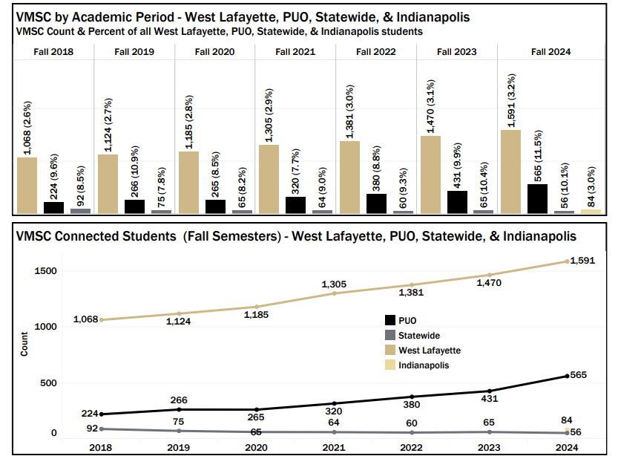

West Lafayette & Indianapolis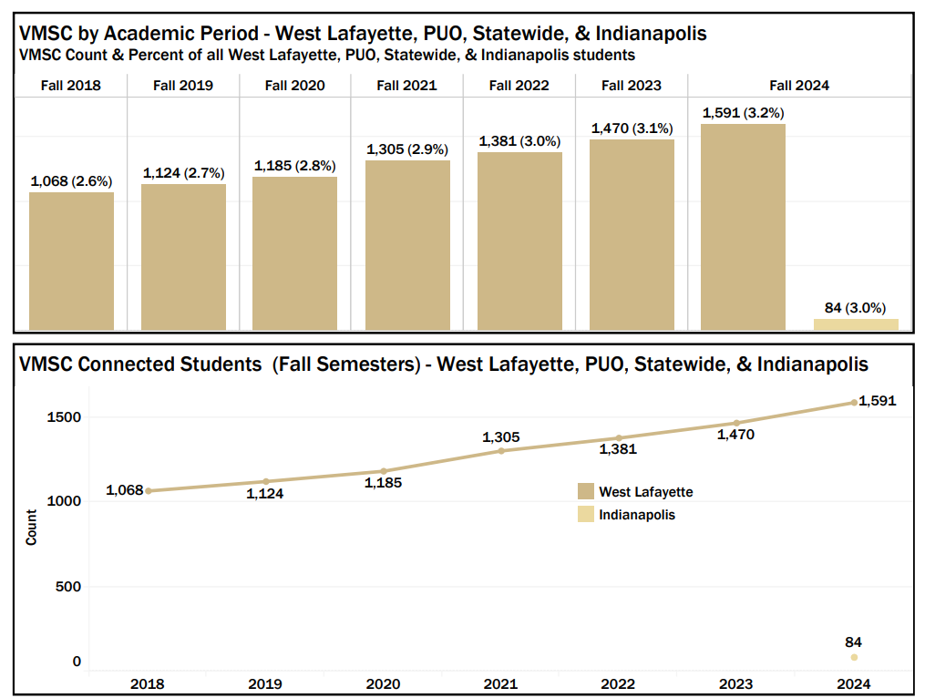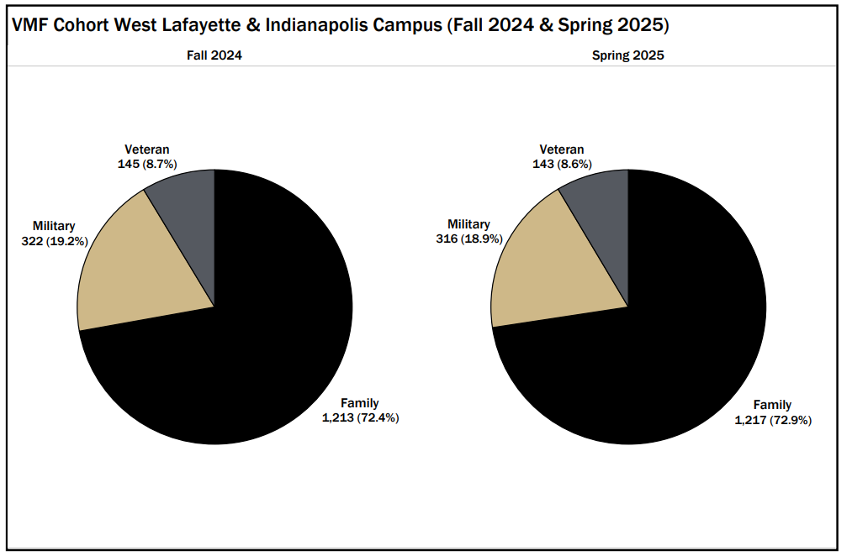

Purdue Polytechnic Statewide
In July 2021, the VMSC assumed responsibility for certifying benefits and helping support military-connected students for the Polytechnic Statewide Tech locations.
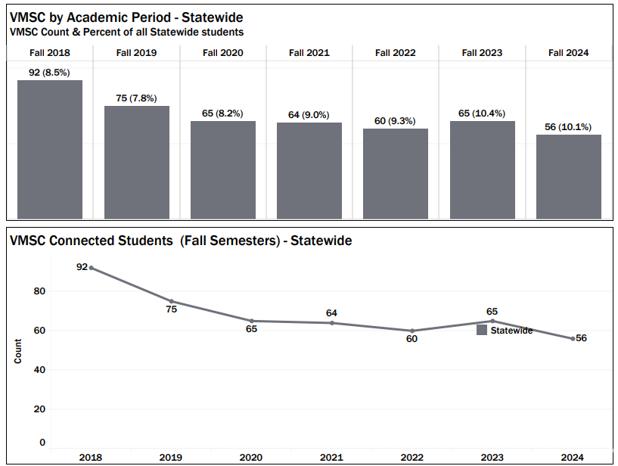
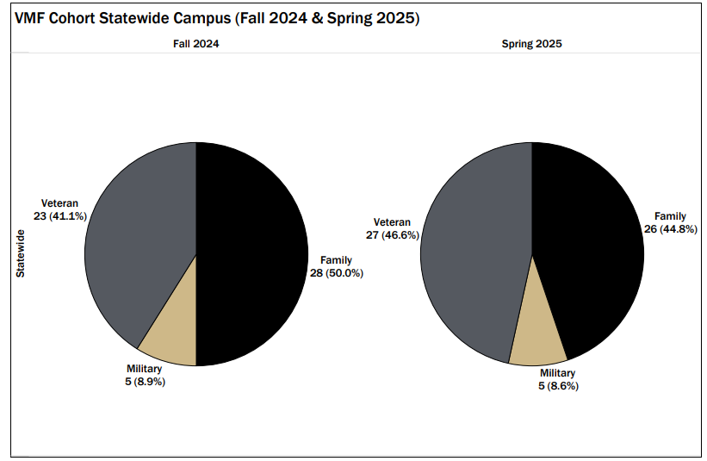

Purdue Online

Note: Beginning in Spring 2024, additional VMSC-connected students have been identified and added to the VMF cohort. Specifically, PUO Graduate students have been recognized through alternative application fields within both Undergraduate Admissions and Purdue Online Graduate records. These records have been updated, allowing these students to be included in prior years, even without an assigned VMF cohort. This update provides a more accurate representation of the total number of students supported by VMSC. Additionally, previous reports combined PUO students with PWL totals. This has now been corrected to report PWL and PUO students distinctly, ensuring greater accuracy in the data.

Purdue Online

